# https://static.wixstatic.com/media/11f439_1008e234ece8470599caef03499cf3a7.png/v1/fill/w_177,h_229,al_c,usm_0.66_1.00_0.01/11f439_1008e234ece8470599caef03499cf3a7.png

**Special Educational Needs Policy**

**2018**

|  |  |
| --- | --- |
| **Contents** | |
| Introductory Statement | Page 3 |
| School Information | Page 3 |
| Rationale | Page 3 |
| Legal Framework | Page 3 |
| Aims of the Policy | Page 3 |
| Inclusion | Page 4 |
| Roles and Responsibilities | Page 4 |
| Enrolment | Page 10 |
| ASD Class | Page 10 |
| Prevention and Early Intervention Strategies | Page 12 |
| Selection Process for Allocating Additional Teaching | Page 12 |
| Meeting the Needs and Allocating Resources | Page 20 |
| Gathering Information and Assessment | Page 21 |
| Tracking, recording and reviewing progress | Page 22 |
| Health and Safety Issues | Page 26 |
| Supervision/Child Protection | Page 26 |
| Ratification and Communication | Page 27 |
| Implementation and Review | Page 27 |
| Appendix 1 | Page 28 |
| Appendix 2 | Page 37 |
| Appendix 3 | Page 38 |

# Introductory Statement

Our SEN Policy was coordinated by the Principal and SET Team, in consultation with all relevant Stakeholders. The review of this policy was carried out in February 2018 after the implementation of the new Special Education Teaching Allocation Model in 2017. The SEN Policy was reviewed in accordance with Circular Number 0013/2017. It will be circulated to staff and made available to families by September 2018 and will be fully implemented from September2018.

**School Information**

St. Mary’s National School is a co-educational primary school under the patronage of the Archdiocese of Dublin. It is a 3 teacher co-educational multigrade mainstream primary school with a Special Class (ASD unit).The school also currently has two additional fulltime SET teachers.

**Rationale**

# The purpose of this policy is to;

* Provide practical guidance to staff, parents and all relevant stakeholders about our SEN procedures and practices.
* Outline the framework in place for addressing additional needs in our school.
* Comply with legislation (Education Act 1998, Equal Status Act, 2000)
* Fulfil DES circular 0013/17 – Circular to the Management Authorities of all Mainstream Primary Schools; Special Education Teaching Allocation and new 2017 Guidelines for Primary Schools; Supporting Children with Special Educational Needs in Mainstream Schools.

**LEGAL FRAMEWORK**

St Mary’s NS sets out to provide education for all its students, with reference to legislation

regarding students with SEN as listed below:

* The Education Act (1998)
* The Education Welfare Act (2000)
* The Equal Status Act (2000)
* The Education for Persons with Disabilities Bill (2003)
* The Equality Act (2004)
* The Data Protection Acts (1988, 1998 and 2003)
* The Freedom of Education Acts (1997 and 2003)
* The Education of Persons with Special Educational Needs Act (2004)

This policy is drafted in the context of:

* DES Circular Letters
* The guidelines published by the NCSE
* The guidelines on the Individual Education Plan Process 2006
* The Guidelines on the Continuum of Support for Primary Schools (NEPS).
* The guidelines published by the Special Educational Needs Support Service (SESS)

AIMS OF THE POLICY

The principal aim of Special Education Teaching in St. Mary’s NS is to provide a positive learning environment, which will foster the academic, social and emotional development of students with learning difficulties and to enable each to realise their individual potential.

Special Education provision also seeks to:

* Enable pupils of all abilities to avail of and benefit from an appropriate education.
* Provide students with consistent opportunities to experience success.
* Provide supplementary teaching and additional support in literacy and numeracy.
* Involve parents in the support of their child’s education.
* Promote collaboration among teachers in the implementation of a whole school policy on learning support for pupils.
* Protect and enhance the self-esteem of the learner.

The school hopes to achieve the following by updating the SEN policy:

* To include the most recent best practice in SEN.
* To reflect the most recent recommendations, most particularly the Continuum of Support at Primary Schools (NEPS).
* To outline our whole school approach to teaching/ learning in relation to pupils with SEN.
* To assist parents in making an informed decision in relation to the enrolment of their child in our school.
* Ensure that students with SEN are educated in an inclusive environment.
* Ensure that all members of staff are aware of the specific needs of students and of the contribution they can make in this area.
* Ensure that SEN is not viewed in isolation, but in the context of the whole school and community.
* Ensure that students with SEN are offered a broad, balanced and differentiated curriculum and that they are provided for in an inclusive way.

Inclusion:

We are fully committed to the principle of inclusion and the good practice which makes it possible. Our policy as set out in this document, aims to enable children with SEN and children whose first language is not English, to become fully integrated members of our school community. This will be achieved by careful consideration of the needs of each child and by either modifying activities or by providing support that will help the child to participate in them.

Roles and Responsibilities

Board of Management

The BoM will fulfil its statutory duties towards pupils with special educational needs. It will ensure that the provision required is an integral part of the school development plan. Members will be knowledgeable about the school’s SEN provision – funding, equipment and personnel. The BoM:

* Oversees the development, implementation and review of school policy on support for children with extra needs
* Provides adequate class accommodation and teaching resources
* Provides a secure facility for storage of records.

Principal

The principal has overall responsibility for the day-to-day management of provision. She will work closely with the SEN team and will keep the BoM informed about the working of this policy. It will be the role of the principal in collaboration with the SEN team to:

* Develop inclusive whole-school policies and monitor their implementation
* Assign staff strategically to teaching roles, including special education roles
* Co-ordinate teachers’ work to ensure continuity of provision for all pupils
* Ensure that whole-school procedures are established to facilitate the effective involvement of parents, pupils and external professionals/agencies
* Ensure that effective systems are implemented to identify pupils’ needs and that progress is monitored methodically
* Facilitate the continuing professional development of all teachers in relation to education of pupils with special educational needs, and ensure that all school staff (class teachers, special education teachers and special needs assistants) are clear regarding their roles and responsibilities in this area

Special Needs Co-ordinator (Principal)

The Special Needs Co-ordinator will be responsible for:

* Overseeing the day-to-day operation of the SEN policy
* Co-ordinating provision for children with special educational needs
* Liaising with and advising fellow teachers and contributing to in-service training of staff
* Liaising with and advising SNAs with regard to supporting children with special needs
* Liaising with parents of children with special needs
* Monitoring and evaluating SEN provision
* Keeps a list of pupils who are receiving supplementary teaching
* Facilitating planning for class teacher with support teacher during Croke Park Hours
* Supports the implementation of a tracking system at a whole-school level to monitor the progress of children who avail of additional support
* Keeps teachers informed about the external assessment services that are available and the procedures to be followed for initial referrals
* Advises parents on procedures for availing of special needs services
* Selects children for psychological assessment in consultation with class and support teachers and with NEPS Psychologist
* Liaises with external agencies such as NEPS to arrange assessments of children with SEN
* Liaises with SENO regarding all aspects of special education provision
* Stores confidential information (Psychological Assessment Reports etc.) regarding SEN children and shares same with class teachers, support teachers, SNAs, other agencies where appropriate.
* Arranges for exemptions from the study of Irish for pupils for whom this is appropriate.

**The Role of the Class Teacher**

Class teaches have primary responsibility for the teaching and learning of **all** pupils in his/her class, including those selected for additional support. They should

* Implement teaching programmes which optimise the learning of all pupils and, to the greatest extent possible minimise the emergence of learning difficulties
* Create a positive learning environment within the classroom
* Differentiate teaching strategies, approaches and expectations to the range of experiences, abilities, needs and learning styles in their class
* Administer and correct standardised tests of achievement in literacy and numeracy, following the schools guidelines
* Discuss outcomes of standardised testing with SEN Team to assist the selection of children for supplementary teaching
* Meet with parents regarding any concerns they may have for their child and update them regarding their progress
* Gather information and assess children presenting with needs to inform teaching and learning using the continuum of support
* Open a student support file once additional needs have been identified and require classroom support
* Develop classroom support plans for children in need of classroom support
* Collaborate with Special Education teachers to develop school support plans for children in receipt of school support
* Collaborate with Special Education teachers to develop School Support Plus plans for each pupil in receipt of school support plus
* Meet regularly with all relevant stakeholders in reviewing relevant education plans
* Where applicable, collaborate with SET team regarding teaching aims and activities for team teaching
* Adjust the class timetable to ensure that children in receipt of supplementary teaching will not be absent for the same subject/activity during each session
* Co-ordinate the role and responsibilities of the SNA in relation to the needs of pupils with SEN and SNA access in their class

**The Role of the Special Education Teacher**

Special education teachers should be familiar with a wide range of teaching approaches, methodologies and resources to cater for particular learning styles and to meet a variety of needs. Teaching approaches will include a combination of team-teaching initiatives, co-operative teaching, early intervention and small group or individual support. Depending on the learning needs identified, a pupil with special educational needs may be supported at classroom level, or through mainstream classroom placement with additional teaching delivered through in-class or withdrawal support models.

Some pupils with more complex and enduring needs may require specific methodologies, teaching approaches and/or learning activities. Such interventions should be based on careful identification of strengths and needs, including multi-disciplinary assessment when necessary**.**

The type of support offered depends on the child’s individual needs and takes the form of:

* curriculum support
* life and/or social skills training
* physical training/gross motor development
* speech training/communication and/or language development
* behaviour modification programmes
* assistance with sensory modulation
* development of anger management strategies
* a combination of some/all of the above
* Collaboration with class teachers to develop School Support Plans for children in receipt of school support
* Collaboration with class teachers to develop School Support Plus Plans for each pupil in receipt of school support plus
* Meet regularly with all relevant stakeholders in reviewing relevant education plans
* Where applicable, collaborate with class teachers regarding teaching aims and activities for team teaching

Special education teachers, in consultation with class teachers, should plan their interventions carefully to address pupils’ priority learning needs and to achieve the targets identified in the relevant continuum of support plan. Short-term planning should reflect the support plan targets and should break down the development of skills and content into small incremental steps to address each pupil’s specific needs on a weekly basis. Outcomes for pupils should be routinely assessed, recorded and used to review progress. These outcomes should also be used to inform the targets for the next phase of intervention.

In addition to consultation around the individual needs of their child, parents also value receiving good information on the nature and type of the special educational needs provision available in the school. Our school will consult with parents when developing and reviewing polices relating to the education of children with special educational needs. This helps to ensure that parents understand the school’s approaches and better enables them to support their children in transitioning through the school.

The SEN Teachers are responsible for:

* Organising the timetable for support teaching
* Liaising with parents of children with special needs
* Supports the implementation of a tracking system at a whole-school level to monitor the progress of children who avail of additional support
* Participates in and or oversees the drafting of classroom support plans, school support plans and school support plus plans.
* Together with the Principal Stores confidential information (Psychological Assessment Reports etc.) regarding SEN children and shares same, class teachers, support teachers, SNAs, other agencies where appropriate.

Parental Involvement

Good parental engagement is a critical factor in enhancing outcomes for pupils with special educational needs. Parental engagement is enhanced when parents are consulted in relation to their children’s needs and strengths, on the supports and strategies being developed to support their children, and when they are involved in regular reviews of progress. The Continuum of Support process and use of the Student Support File provide valuable opportunities to engage with parents and to build a collaborative approach to identifying and responding to the needs of pupils with special educational needs. There may also be opportunities for parents to work collaboratively with the school through initiatives such as paired reading.

The Parents/Guardians of the pupils of St. Mary’s NS can prepare for and support the work of the school by:

* Supervising, assisting with, showing interest in and signing homework.
* Reading and telling stories to their child/children.
* Listening to and giving supportive feedback on reading.
* Where their child is in receipt of supplementary teaching, implementing suggested home-based activities and discussing the outcomes with the child’s teachers.
* Signing and returning consent forms to the school regarding withdrawal for support teaching.
* Talking positively about school and school work.
* Keeping the class teacher informed of any home factors which may be affecting their child’s progress.
* Participating in activities organised by the school that are designed to increase the involvement of parents in their children’s learning.
* Helping children to develop their organisational skills.
* Helping children to look after school books and other resources which are loaned to the children for use at home.
* Supporting programmes and initiatives implemented by the school.

**Special Needs Assistants**

The duties of the SNA are carried out according to the guidelines for Special Needs Assistants from the Department of Education and Skills under the direction of the principal/class teachers. The SNA will meet the care needs of the pupils to which they have been assigned (Circular 10/76)

The SNA should

* Support the needs of pupils in effectively accessing the curriculum
* Contribute to the quality of care and welfare of the pupils
* Support learning and teaching in the classroom
* Attend where possible, training courses/workshops
* Attend IEP meetings or meetings with relevant professionals, when necessary
* Ensure safety of SEN pupils in the school yard, and be present for the duration of the yard breaks along with the teachers on duty
* Maintain a record of support provided to their SEN pupil
* Accompany SEN pupil to supplementary lessons if appropriate

Enrolment

The school aims to meet the needs of any child whom the parent wishes to register at the school as long as a place is available and the admission criteria are fulfilled. The Education For Persons with Disabilities Act 2004 states that ‘A child is entitled to attend the school which is most suited to his or her overall needs’.

Parents are required to notify the school of their child’s special needs in advance of enrolment through the school principal. The Board of Management will request a copy of the child’s medical or psychological report. No child will be refused admission solely on the grounds that s/he has SEN except where the provision required is incompatible with that available in our school.

**ASD Class**

St Mary’s NS has an ASD Class, which caters for children with autism spectrum disorder. The maximum enrolment in the class is 6 pupils and is staffed by 1 teacher and 2 SNAs. The pupils in the ASD Class are integrated with other pupils at yard time, assembly, mass, school trips and through integration with the mainstream class when suitable.

Pupils follow their IEP which is written up after intensive assessment using ABLLS in conjunction with the Curriculum for Mild/ Moderate General Learning Difficulties where appropriate.

**Referral Procedure**

Children are referred to an ASD Class by a clinical psychologist, who will recommend a special setting if they believe the child is unable for a mainstream class. The parents can apply directly to the school by filling out an Enrolment Form. A Psychological report, written within the last 3 years, stating that the child meets the DCM V criteria for ASD as well as stating that the child needs to attend a special setting (ASD school or ASD Class) must be submitted with the Enrolment Form. If the class is full, the child is put on a waiting list.

**Selection of Applicants for Admission**

Should a space become available in the ASD Class, the Admissions Team meet to go through the children on the waiting list. A place will be offered to a child based on the criteria set out in the school’s Enrolment Policy. Parents are asked to either accept/ decline the place within one week of receipt of the offer. Where an offer is declined, the place will be offered to the next child on the waiting list based on the criteria set out in the Enrolment Policy.

All pupils are accepted on the understanding that they and their parents fully accept the school’s Code of Discipline, and all other policies currently in place, or which may be drawn up by the Board of Management.

Pupils in the ASD Class will experience the normal day to day happenings and the existing customs and practices where possible. Every child in the school is bound by school policies, both in existence and those developed from time to time by the Board of Management. The school cannot offer any additional tuition, support and supervision beyond that which is offered to any other pupil in the school. The Class Teacher will at times be required to participate in Continued Professional Development. On these days, suitable cover will be arranged for the ASD Class and a normal school day will take place. From year to year, the allocation of teachers and SNAs is focused on the needs of the whole school, and consequently the school cannot guarantee long term continuity or predictability in personnel.

**School Transport**

All children in the ASD Class are entitled to free transport. Applications are made through the NCSE. The school has responsibility for providing a bus escort where needed.

**Transition to Mainstream Education**

Our goal is to include all children in mainstream settings where possible. The child to be integrated, as well as those already in the mainstream setting, best interests are considered. Should the ASD Class Teacher, the School Principal and the Mainstream Class Teacher feel that a child can be integrated for periods of time, the Principal will contact the parents and inform them. Should the school feel that a child can transition into the mainstream setting permanently, other professional opinions will be sought. These will include the Clinical Psychologist, the school’s NEPS psychologist and any other Therapist which may have worked with the child. The possibility of resource hours, as well as SNA support, will be organised prior to the transition.

**Whole School Strategies to minimise learning difficulties and Early Intervention**

Our strategies for preventing learning difficulties include:

* Development of agreed approaches to teaching Literacy and Numeracy in order to ensure progression and continuity from class to class.
* Provision of additional support in Language Development and any relevant early literacy and mathematical skills to those who need it.
* Ongoing structured observation and assessment of the language, literacy and numeracy skills of pupils in the infant classes to facilitate early identification of possible learning difficulties.
* Close collaboration and consultation between the teachers and SET Team.
* Promotion of Literacy e.g print rich environment, DEAR, structured whole school approach to levelled guided reading structured whole school approach to writing genre instruction (see SIP) explicit teaching of comprehension strategies through guided reading and lessons, world book day, book fair, explicit oral language lessons, Aistear.
* Hands on approach in the teaching of maths, use of concrete materials and small, differentiated group teaching where possible.
* Parental involvement in promoting literacy and numeracy e.g useful links on school website
* Differentiation – adapting the learning environment.
* In-class support from the SET team /team teaching– when possible
* Aistear
* Withdrawing individuals and groups

Selection Process for Allocating Additional Teaching Support

**Continuum of Support**

We use the Continuum of Support Framework set out by the Department of Education to identify and support children with additional needs. Like this framework, we recognise that special educational needs occur along a continuum, ranging from mild to severe, and from transient to long-term and that pupils require different levels of support depending on their identified additional needs. By using this framework, it helps us implement a staged approach to ensure that our support and interventions are incremental, moving from class-based interventions to more intensive and individualised support, and are informed by careful monitoring of progress.

The Continuum of Support is a problem-solving model of assessment and intervention that enables us to gather and analyse data, as well as to plan and review the progress of individual pupils.

Stage One – Classroom Support

Class teachers initially discuss their concerns with the child’s parents.

|  |
| --- |
| The triggers for this intervention could be; |
| * The child makes little or no progress even when teaching approaches are directed at an identified area of weakness * The child shows signs of difficulty in developing literacy and numeracy skills, which result in poor attainment * Persistent emotional or behavioural difficulties which do not respond to behaviour management techniques used by the school * Has sensory or physical difficulties * Has communication and/ or relationship difficulties |

The class teacher completes a Stage One form (Classroom Support Plan) and monitors the Record of Differentiated Support for a term. If this strategy does not work then the teacher will continue to the next stage, School Action – in consultation with the Principal and SET Team.

Teachers inform Parents that their child’s needs would be better served in a small group with a support teacher. Parents will need to sign their consent.

Stage Two – School Support

|  |  |
| --- | --- |
| Selection Process | Type of Support |
| * Prevention and Early Intervention Programs (Aistear, station teaching, small group teaching at infant level, team teaching, in class support for literacy and maths) * Children in JI & SI whom English is an additional Language or newly arrived EAL students from 1st – 6th classes * Children on or under the 10th %ile in standardised tests in Reading * Children with an identified need assessed by an external professional in literacy who are not on or below the 12th percentile such as; Borderline Mild General Learning Disability, mild general learning disability, specific learning disability, attention deficit disorder, attention deficit hyperactivity disorder. * Children on or under the 10th %ile in standardised tests in Mathematics * Children who have not made adequate progress after interventions at stage 1 | In - class support  Team teaching  Group withdrawal  Individual withdrawal  Personnel  SET Teacher  Class Teacher |

Stage 3 – School Support Plus

|  |  |
| --- | --- |
| Selection Process | Type of Support |
| * Children with identified complex needs by an external professional such as a; * Physical Disability * Hearing Impairment * Visual Impairment * Emotional Disturbance * Moderate General Learning Disability * Severe/profound General Learning Disability * Autistic Spectrum Disorder * Assessed Syndrome * Specific Speech and Language Disorder/Impairment | In - class support  Team teaching  Group withdrawal  Individual withdrawal  Personnel  SET Teacher  Class Teacher |

This problem-solving process is illustrated as follows:

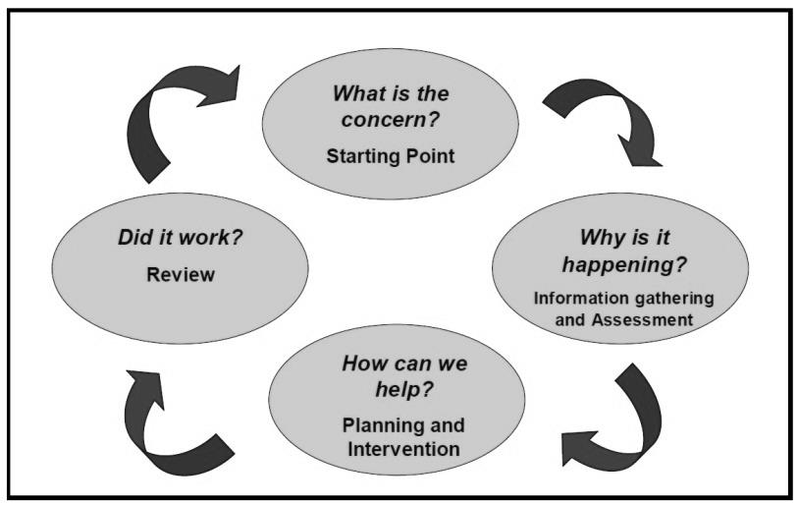

Identification of educational needs is central to our policy and the new allocation model. By using the Continuum of Support framework, we can identify pupils’ educational needs, to include academic, social and emotional needs, as well as needs associated with physical, ­­­­sensory, language and communication difficulties. This, in turn, allows us to identify and respond to needs in a flexible way.

**The Continuum of Support suggests the following levels of support:**

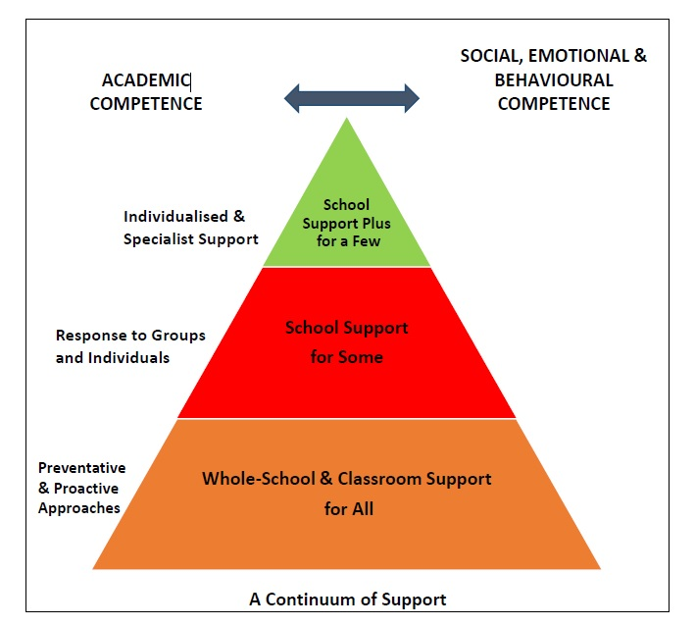

***STAGE 1 CLASSROOM SUPPORT***

Classroom Support is the most common, and typically the first response to emerging needs. It is a response for pupils who have distinct or individual educational needs and who require approaches to learning and/or behaviour which are **additional to or different** from those required by other pupils in their class. Problem-solving at this level typically begins when a parent or teacher has concerns about an individual pupil. The teacher, SET and parents discuss the nature of the problem and consider strategies which may be effective. Classroom Support incorporates the simple, informal problem-solving approaches commonly used by class teachers to support emerging needs e.g. traffic light system, seating in class, individual reward system, and organisational folder.

***STAGE 2 SCHOOL SUPPORT***

In some cases, interventions at classroom support level are not enough to fully meet the pupil’s special educational needs. School Support may, therefore, be required. The class teacher needs to involve the Special Education Teacher Team (SET Team) in the problem-solving process at this point and it involves more systematic gathering of information and the development and monitoring of a School Support Plan.

***STAGE 3 SCHOOL SUPPORT PLUS***

If a pupil’s special educational needs are **severe and/or persistent**, they are likely to need intensive support. School Support Plus will generally involve personnel outside the school team in the problem solving, assessment and intervention process. However, the information from Classroom and School Support work will provide the starting point for problem-solving at this level. Classroom support and school support will continue to be an important element of his/her individual education plan.

The flow diagrams below outline how we gather information to identify needs and support children with additional needs. A more comprehensive explanation of each stage can be in the Continuum of Support – Guidelines for teachers

<https://www.education.ie/en/Schools-Colleges/Services/National-Educational-Psychological-Service-NEPS-/neps_special_needs_guidelines.pdf>

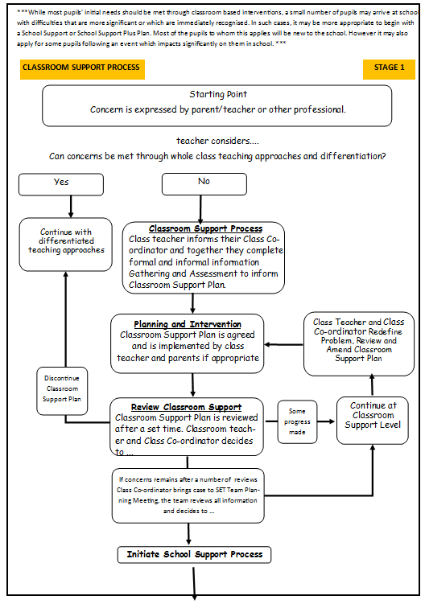

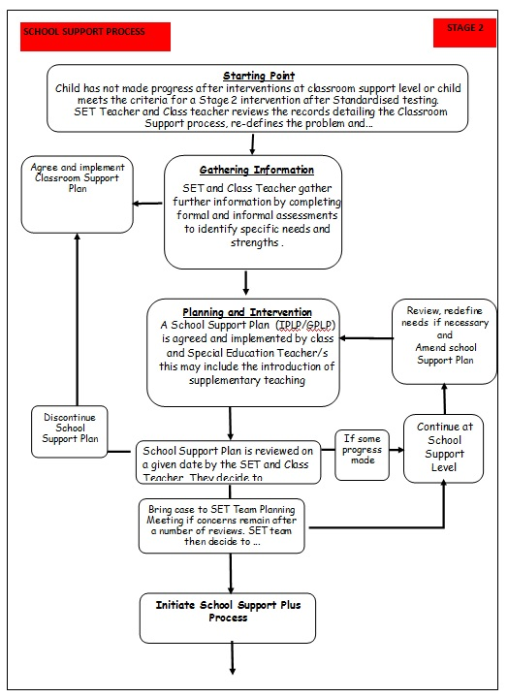**\*** adapted from NEPS Continuum of Support.

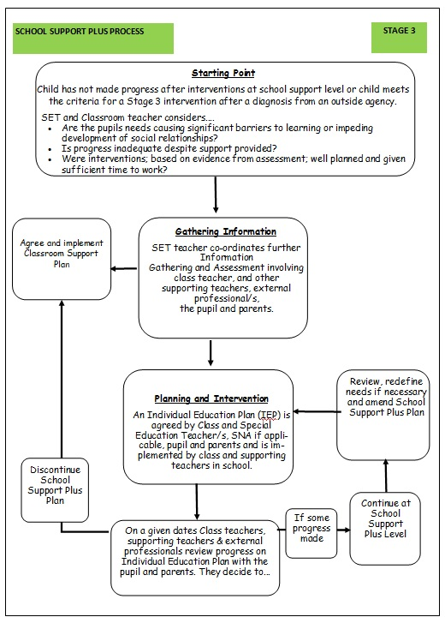**\*** adapted from NEPS Continuum of Support.

**Meeting the Needs and Allocating Resources**

Once pupils needs have been identified, Special Education Teachers (SETs) are deployed to address these needs as required. We deploy SETs in a variety of ways in order to effectively meet pupils’ needs. We aim to strike a balance between in-class support, group and individual support (when/where possible) while ensuring that the needs of children

with additional needs are met inclusively.

Importantly, the level and type of support reflect the specific targets of individual pupils as set out in their support plans and are informed by careful monitoring and review of progress. In this way, following a period of intervention, some pupils may no longer require additional teaching supports; some may require the same level, while others may require more intensive supports.

In planning the allocation of additional teaching supports, the over-riding principle is that resources are deployed to address the identified needs of pupils. Importantly, those with **the highest level of need should** **have access to the greatest level of support**. We consider methodologies best suited to promoting meaningful inclusion such as differentiation, heterogeneous grouping, team-teaching and small group teaching.

In addition to literacy and numeracy difficulties, many pupils will have specific needs in such areas as oral language, social interaction, behaviour, emotional development, motor skills and application to learning.

At the end of each term the SET Team meet class teachers and review children’s needs, the resources in place and progress made using the Continuum of Support problem-solving model of assessment and stage approach flow charts. The SET team then bring this information to the end of term SET team planning meetings. As a SET team, we review all support and allocate resources for the subsequent term.

We cross-reference the needs of pupils at School Support and School Support Plus levels and consider common needs that can be met by grouping, to ensure effective and efficient teaching and learning approaches.

Gathering Information and Assessment

Assessment is part of what a class teacher does on a daily basis for all children. Some methods include self-assessment, questioning, teacher observation, portfolios and teacher designed tasks and tests. The information gathered enables the teacher to plan learning experiences based on the appropriate objectives from the curriculum.

In order to identify pupils who may require supplementary teaching, screening, including standardised testing, is carried out in all classes annually and further diagnostic testing may need to take place. The information gathered from these formal assessments is then used to inform decisions for support and pupil’s support plans (CSP, IPLP/GPLP and IEP)

Assessment and Screening Tests

In our school we carry out the following assessment procedures on all children

* Junior Infants; Observation and Checklists
* Senior Infants; Observation, Checklists, MICRA T MIST
* 1st class; Observation and Checklists, MICRA T, SIGMA T
* 2ND class; Observation and Checklists, , SIGMA T, NRIT(old), MICRA T
* 3rd Class; Observation and Checklists, MICRA T and SIGMA T
* 4th Class; Observation and Checklists, MICRA T and SIGMA T
* 5th Class; Observation and Checklists, NRIT (old) MICRA T and SIGMA T,
* 6th Class; Observation and Checklists, MICRA T and SIGMA T

We continually review the assessment and screening tests that we use in order to balance the needs of our pupils and the need to provide information for appropriate support. Therefore we may deviate from the above list prior to the review date

Inventory of Test Materials Used

Screening Tests

|  |  |
| --- | --- |
| MIST | Sigma T |
| Drumcondra Early Numeracy / Literacy | MICRA |
| Drumcondra English | Drumcondra Maths |

Diagnostic Tests

In our school the following tests are available for administration

|  |  |
| --- | --- |
| Jackson Phonics | Belfield Infant Assessment Folder |
| NEAL Analysis | Dromcondra Spelling |
| NRIT | EAL Primary School Assessment Kit |
| NEWELL | Schonnell |
| Non Verbal Reasoning | Assessment of Comprehension &Expression (6-11) |
| Aston Index | Bracken Basic Concept Scale |

**Tracking, recording and reviewing progress**

Provision for pupils with special educational needs is enhanced through clear identification processes and careful planning of interventions to address academic and/or personal and social development needs. Identification of needs, planning, target-setting and monitoring of outcomes are essential elements of an integrated and collaborative problem-solving process.

**Student Support File**

We use a Student Support File to plan interventions and to track a pupil’s pathway through the Continuum of Support. It facilitates us in documenting progress and needs over time and assists us in providing an appropriate level of support to pupils, in line with their level of need. Our Student Support File is based on the NEPS template – template copies will be stored on the Dropbox account. Hard copies will be stored in Class Continuum Folders

All Continuum Folders should include:

* Cover sheet
* Class List
* Whole Class Continuum of Support overview
* Whole Class Standardised results
* **Individual Student Support Files –***(to include a timeline of actions and record of support received)*

Pupil Profile Page

Classroom Support Plan / Care Plan (as necessary)

IPLP / GPLP (as necessary)

IEP (as necessary)

Checklist (as necessary)

Standardised/ Diagnostic test scores

* Sample Documents
* Blank Documents

A class teacher or class coordinator should open a Student Support File once a child is placed on Stage 1 –Classroom Support on the continuum. Paper copies are stored securely in the Schools Continuum of Support Folders. At the end of the year, information gathered and Continuum Folders are filed in the office. All assessments are kept in the child’s file in the office and are available on request via the SENCO.

It is the responsibility of the class teacher and the allocated SET to access and update the information in the Student Support File.

**Support Plans**

We use three different support plans for the three stages of support on the Continuum of Support.

***Stage 1 – Classroom Support***

**Classroom Support Plan**. (CSP) This is a simple plan which is drawn up by the Class Teacher in collaboration with the SEN Class Coordinator which outlines the pupil’s additional educational needs and the actions, including individualised teaching and management approaches, which will be taken to meet the pupil’s needs. The plan may also include home-based actions to be taken by the pupil’s parents to support their child’s development. The Classroom Support Plan should include a review date. This could be at the end of a school term.

***Stage 2 – School Support***

**Group or Individual School Support Plan** **(SSP).** *IPLP / GPLP***-** This plan is drawn up by the class teacher and appointed SET teacher. It will set out the nature of the pupil’s learning difficulties, define specific teaching, learning and behavioural targets and set a timescale for review. The plan should, for the most part, be implemented within the normal classroom setting and complimented by focused school based intervention programmes. Depending on the nature of the needs and on the school context, additional teaching might be within a small group or individual or a combination of both either in class or on a withdrawal basis. Home-based actions may also be included. After the plan has been drawn up, it should become a working document through the careful monitoring of the pupil’s response to the actions taken.

***Stage 3 – School Support Plus***

**A School Support Plan Plus (SSPP)** *IEP* -This plan is drawn up by the class teacher and appointed Special Education Teachers, in consultation with the child’s parents/guardians, professionals external to the school and (if appropriate) the child based on the information gathered. It will set out;

* The nature and degree of the pupil’s abilities, skills and talents
* The nature and degree of the pupil’s special educational needs and how those needs affect his/her educational development
* The present level of educational performance of the pupil
* The special educational needs of the pupil
* The special education and related support services to be provided to the pupil to enable the pupil to benefit from including:
* Strategies for supporting the pupil’s progress and inclusion in the classroom setting
* Individual and/or small group/special class interventions/programmes
* Specific methodologies/programmes to be implemented
* Specific equipment/materials and/or IT supports, if required to support learning and access to the curriculum
* Support required from a Special Needs Assistant (SNA), if appropriate
* The goals which the pupil is to achieve over a period not exceeding 12 months
* The pupil’s priority learning needs, long and short term targets to be achieved, the monitoring and review arrangements to be put in place

IEP meetings are coordinated by an appointed IEP coordinator. This is usually one of the child’s Special Education Teachers. Parents will be invited to at least two out of three meetings depending on the needs of the child.

IEP CYCLE

**SEN Records**

***Individual SEN Files***

All pupils’ SEN files are stored in a **locked filing cabinet in the Principal’s office**. **No SEN files should be saved to teachers laptops.** It is the responsibility of SETs to update and manage the files of the children on school support and school support plus that they support. It is the responsibility of the SEN teacher/ SENCO and class teacher to update and manage the SEN files of children on classroom support. The following should be stored

* Student Support File
* Psychological Report
* Copy of referrals made to outside agencies
* Copy of reports from outside agencies
* Record of SEN meetings with parents, outside agencies and inter- school meetings
* Record of SEN correspondence between parents, outside agencies and school staff

***Whole Class SEN Files***

Whole class SEN records are stored securely in Class Continuum of Support Folder with the class teacher. It is the responsibility of both the class teacher and the SEN Teachers to manage and update these. The following should be stored in these Continuum Folders:

* Cover sheet
* Class List
* Whole Class Continuum of Support overview
* Whole Class Standardised results
* **Individual Student Support Files –***(to include a timeline of actions and record of support received)*

Pupil Profile Page

Classroom Support Plan / Care Plan (as necessary)

IPLP / GPLP (as necessary)

IEP (as necessary)

Checklist (as necessary)

Standardised/ Diagnostic test scores

* Sample Documents
* Blank Documents

***Communication between SET Team/Principal/Class Teachers***

SET timetables have been organised so that 2.00-2.40 each Friday is our designated co-ordination time. This allows all staff the opportunity to attend pupils support planning meetings, Team Teaching Planning Meetings, SEN Teachers meetings and SEN consultation/planning/review meetings, when necessary. This flexibility ensures adequate cover for class teachers and also facilitates regular SET team planning meetings with the principal.

**Health and Safety Issues**

Every staff member and pupil is entitled to a safe, secure environment and to be treated with due respect. All appropriate measures are taken to ensure the safety of each pupil with SEN. When a place is offered to a child with SEN, every effort will be made to ensure that the supports to which the child is entitled are in place as soon as possible. Staff members will be informed of any potential risks and, where necessary, individual plans will be drawn up and implemented.

**Supervision/Child Protection**

* Where pupils receive support on a one-to-one basis, the SET teacher is responsible for ensuring that both themselves and the pupil are visible through the glass panel in the door.
* Parental Permission will be sought for one-to-one teaching
* Where there is no glass panel, the door of the room should remain open.
* There will be a desk between the teacher and the student where possible.
* Where pupils are withdrawn for support, the SET teacher should collect and return children to their classrooms.
* Where a child has access to an SNA, they may withdraw the child from the class if a plan is in place with the class teacher.

This policy will be reviewed every three years.

|  |  |
| --- | --- |
|  | Date |
| Staff Consultation |  |
| Parental Consultation |  |
| Ratified by BoM |  |

Signed: ____________________________________

Chairperson, BoM

Date: _________________________

|  |  |  |
| --- | --- | --- |
| **School Support Plan**  **St. Mary’s N.S. Oldtown** | | |
| **Student’s Name:** | **Age:** | **Start**  **Date:** |
| **Lead Teacher:** | **Class:** | **Review**  **Date:** |
| **Student’s Strengths & Interests**: | | |
| **Priority Concerns:** | | |
| **Possible Reasons:** *(Essential references: ‘SEN: A Continuum of Support – Resource Pack for Teachers’ pp. 18-21; ‘BESD: A Continuum of Support – Guidelines for Teachers’ pp. 80-108)* | | |
| **Targets we want to achieve:** | | |
| **Strategies we will use:** (*SEN- A Continuum of Support- Guidelines for Teachers p23; BESD: A Continuum of Support-Guidelines for Teachers (pages 111-139)* | | |
| **Staff Involved & Resources Needed:** | | |
| **Signed:**  **Parent(s): ______________________________________________________________________­­­­______**  **Teacher(s): ___________________________________________________________________________** | | |

**Appendix 1 – Templates of Documents used to support The Schools Continuum of Support**

|  |  |  |
| --- | --- | --- |
| **St. Mary’s N.S. Oldtown**  **Support Checklist** | | |
| **Name:** | | **Class:** |
| **General Information** | **Checked** | **Comments** |
| 1. Parents/ Guardians Consulted |  |  |
| 1. Information from previous school/preschool gathered |  |  |
| 1. Hearing |  |  |
| 1. Vision |  |  |
| 1. Medical Needs |  |  |
| 1. Basic Needs Checklist completed |  |  |
| 1. Assessment of learning- screening |  |  |
| 1. Observation of learning style/approach to learning |  |  |
| 1. Observation of behaviour |  |  |
| 1. Interview with pupil |  |  |
| 1. Classroom work differentiated? |  |  |
| 1. Learning environment adapted? |  |  |
| 1. Yard/school environments adapted? |  |  |
| 1. Informal or formal consultation/advice with outside professionals? |  |  |
| 1. Advice given by learning support/resource teacher or other school staff? |  |  |
| 1. Other interventions put in place in school? |  |  |
| **Action needed** |  |  |

**St. Mary’s N.S. Oldtown**

**Support Review Record**

**To be completed by the teacher(s) as a review of the plan and as a guide for future actions.**For help, see *‘SEN: A Continuum of Support - Guidelines for Teachers’, ‘BESD: A Continuum of Support – Guidelines for Teachers’, ‘ A Continuum of Support for Post-Primary Schools, Resource pack for Teachers’, ‘Student Support Teams in Post-Primary Schools’.*

|  |  |  |  |
| --- | --- | --- | --- |
| Student’s Name: | | Class/ Year: |  |
| Names of those present at review: | | Date of Review: | |
| What areas of the plan have been most successful and why? | | | |
| Since the start of the plan, has anything changed in relation to the original concerns? If so, what are these changes, and what have we learned from them? | | | |
| Have the student’s needs changed since the start of the plan? If so, how? | | | |
| Recommended future actions – what, how, who, when? | | | |
| Any comments from the student? | | | |
| Any comments from the parent(s)/guardian(s)? | | | |
| Signature of parent(s)/ guardian(s): |  | | |
| Signature of teacher(s): |  | | |

|  |  |  |  |
| --- | --- | --- | --- |
| Outcome of Review (tick as appropriate): | | | |
|  | Revert to previous level of support- Support for All/ Classroom Support OR Support for Some/ School Support |  | Progress to next level of support- Support for Some/ School Support OR Support for a Few/ School Support Plus |
|  | Continue at Current Level of Support |  | Request consultation with other professionals |

*A consultation with a NEPS psychologist/ other professionals may contribute to this review

**St. Mary’s N.S. Pupil Profile**

|  |  |  |
| --- | --- | --- |
| **Name** | | **DOB** |
| **Date of Enrolment** | | **Medical Needs:**  **________________________**  **________________________**  **________________________**  **________________________**  **________________________** |
| **Assessment Date(s)__________________**  **Recommendations:**  **Special Class SNA Irish exemption**  **Support Other ________________________**  **_________________________________________** | |
| **Strengths** | **Interests** | |
|  |  | |

**School Support / Outside Agencies**

|  |  |
| --- | --- |
| **J.I.** | **Classroom Plan Support Teacher SLT OT SNA**  **Details: ___________________________________________________**  **(other)** |
| **S.I.** | **Classroom Plan Support Teacher SLT OT SNA**  **Details: ___________________________________________________**  **(other)** |
| **1st** | **Classroom Plan Support Teacher SLT OT SNA**  **Details: ___________________________________________________**  **(other)** |
| **2nd** | **Classroom Plan Support Teacher SLT OT SNA**  **Details: ___________________________________________________**  **(other)** |
| **3rd** | **Classroom Plan Support Teacher SLT OT SNA**  **Details: ___________________________________________________**  **(other)** |
| **4th** | **Classroom Plan Support Teacher SLT OT SNA**  **Details: ___________________________________________________**  **(other)** |
| **5th** | **Classroom Plan Support Teacher SLT OT SNA**  **Details: ___________________________________________________**  **(other)** |
| **6th** | **Classroom Plan Support Teacher SLT OT SNA**  **Details: ___________________________________________________**  **(other)** |

**Intervention Log**

|  |  |  |
| --- | --- | --- |
| **Date** | **Details** | **Outcomes** |
|  |  |  |
|  |  |  |
|  |  |  |
|  |  |  |
|  |  |  |
|  |  |  |
|  |  |  |
|  |  |  |

**Appendix 1 – Sample Documents used to support the Continuum of Support**

**Class: Class Teacher: Continuum of Support - Class Profile Date Started: Sept Date Review: Feb**

| **Names** | **Basic Needs** | **Medical Needs** | **Behaviour** | | | | | | | | **Curricular** | | | **Action Taken** |
| --- | --- | --- | --- | --- | --- | --- | --- | --- | --- | --- | --- | --- | --- | --- |
| **Following Instructions** | | **Class Behaviour** | | **Organisation Skills** | | **Peer Relationships** | | **Standardised test results.** | | |
| **MICRA T**  **SS** | **SIGMA**  **T**  **SS** | **NRIT**  **Q.SS** |
| **Sept** | **Feb** | **Sept** | **Feb** | **Sept** | **Feb** | **Sept** | **Feb** |
|  |  |  |  |  |  |  |  |  |  |  |  |  |  |  |
|  |  |  |  |  |  |  |  |  |  |  |  |  |  |  |
|  |  |  |  |  |  |  |  |  |  |  |  |  |  |  |
|  |  |  |  |  |  |  |  |  |  |  |  |  |  |  |
|  |  |  |  |  |  |  |  |  |  |  |  |  |  |  |
|  |  |  |  |  |  |  |  |  |  |  |  |  |  |  |

**St. Mary’s NS, Oldtwon - Classroom Support Plan**

**Name: Teacher: Class: Date:**

|  |  |  |  |  |
| --- | --- | --- | --- | --- |
| **Concern** | **Strategy** | **Term 1 Review**  **Date:** | **Term 2 Review**  **Date:** | **Term 3 Review**  **Date:** |
|  |  |  |  |  |
|  |  |  |  |  |
|  |  |  |  |  |
|  |  |  |  |  |

**St. Mary’s NS Oldtown- Classroom Support and Care Plan**

|  |  |  |  |  |  |  |  |
| --- | --- | --- | --- | --- | --- | --- | --- |
| **Name of Pupil** |  | **Class Teacher:** |  | **Class:** |  | **Start Date:** | **Review Date 2:** |
|  |  |
| **Support Teacher:** |  | **Review Date 1:** | **Review Date 3:** |
| **D.O.B.** |  | **SNA:** |  | **Outside Agencies**  *i.e. CAMHS, OT, SLT* |  |  |  |

**School supports in place**

|  |  |  |  |  |  |
| --- | --- | --- | --- | --- | --- |
| **Term 1** | *Please Tick✓* | **Term 2** | *Please Tick✓* | **Term 3** | *Please Tick✓* |
| **Support** | *✓* | **Support** |  | **Support** |  |
| **Details** |  | **Details** |  | **Details** |  |
| **SNA Access** | *✓* | **SNA Access** |  | **SNA Access** |  |

**Pupils School Routine**

|  |  |  |  |  |  |  |  |
| --- | --- | --- | --- | --- | --- | --- | --- |
| **Morning** | *Details* | **Between Breaks** | *Details* | **Yard** | *Details* | **Afternoon** | *Details* |
| Approx. Daily Arrival Time | 9:20 | Attends Support and type: |  | Does pupil attend yard? |  | Attends Support and type: |  |
| Attends Support and type: |  | Differentiated Work in class: |  | Does SNA supervise on yard? |  | Differentiated Work: |  |
| Differentiated Work in class: |  | SNA Support: |  | If yes,  from a distance or remain close? |  | SNA Support: |  |
| SNA Support: |  | Teacher Support: |  | Teacher Support: |  |
| Teacher Support: |  | Goes home alone / picked up? |  |
| **Any other relevant information:** | | **Any other relevant information:** | | **Any other relevant information:** | | **Any other relevant information:** | |

**Concerns**

|  |  |  |  |  |  |  |  |
| --- | --- | --- | --- | --- | --- | --- | --- |
| **Medical Needs**  OMA and ENT | | | | | **Motor Difficulties** | **Social, Emotional or Behavioural Needs** | **Toileting Needs** |
| *Medication Administered* | | *If yes, what type* | | | *Give Details* | *Give Details* | *Give Details* |
| **Yes** | **No** | **Parental consent** | **Yes** | **No** |
|  |  |  |  |

**Details of concerns and strategies in place to support these**

|  |  |  |  |  |
| --- | --- | --- | --- | --- |
| **Concern** | **Strategy** | **Term 1 Review**  **Date:** | **Term 2 Review**  **Date:** | **Term 3 Review**  **Date:** |
|  |  |  |  |  |
| **Any other information relevant to review** *e.g. attendance, punctuality, illness, change in behaviour, assessment etc.* | | | | |
|  | | | | |

**Appendix 2: Target-setting as part of the problem-solving-framework**



Targets are informed by information gathering and assessment

**How do we evaluate targets?**

Standardised tests

Screening tests

Observations

Interviews

Teacher measures

Check lists

Consultation

Ratings

Evaluation of child’s response to targets informs the next step of the problem-solving cycle

**What informs targets?**

Standardised tests

Screening tests

Observations

Interviews

Teacher measures

Check lists

Consultation

Ratings

**What data can help us set targets?**

Standardised tests

Screening tests

Observations

Interviews

Teacher measures

Check lists

Consultation

Ratings

**Targets are written as desired skills which are**:

**S**pecific

**M**easurable

**A**chievable

**R**elevant

**T**ime Limited

**Targets should be expressed in definitive language to facilitate monitoring and review of progress,** *for example:*

*John will correctly identify the first 50 Dolch Words with 80% accuracy*

*Sean will speak in a full sentence which includes a subject, verb and object*

*Anne will use her PECS to request an activity break*

**Appendix 3: Exceptional Ability & Giftedness Policy**

**Exceptional Ability & Giftedness Policy**

**Definition and Background:**

‘An able child is one that achieves or has the ability to achieve at a level significantly in advance of their peer group. This may be in all areas of the curriculum or in a limited range’. (Eyre, 1999)

* Children who are considered gifted may have been assessed by a psychologist and found to have a high level of intelligence (an IQ score of 130+, 98th Percentile)
* Giftedness is recognised as a ‘disability’ or special education condition in the Education Act (1998).

**School Ethos:**

We, the teaching staff at St. Mary’s NS have agreed, where feasible to cater for those pupils who are exceptionally able in **academic** areas (i.e. the top 2% of the school population).

Those pupils who show exceptional talent in **non-academic** areas e.g. psychomotor ability, mechanical aptitude, visual and performing arts ability, will be given information regarding the relevant outside agencies.

**Procedure for identification of pupils with Exceptional Ability**

**Criteria for Assessment:**

1. A range of strategies may be used to identify exceptionally able pupils:

* Annual standardised tests
* NRIT
* Psychological Assessments
* Teacher observation
* Parental requests
* Referral by other individuals, schools or organisations.

2. From first class onwards, pupils who score on or above the 98th percentile in the MICRA **and** SIGMA tests will then do the NRIT, to gain a more definitive guide of their ability.

3. Where a teacher observes children displaying exceptional ability in a specific academic area, then further assessment may be carried out to establish giftedness. Where it is a non-academic area, the parent will be informed of outside agencies more suited to the development of the pupil’s giftedness.

**Catering for Pupils with Exceptional Ability:**

Pupils who meet the criteria for exceptionally able (IQ of 130+) will be catered for within the classroom based on a differentiated programme of work **or** if deemed possible by the Principal may be offered extension classes on a withdrawal basis, subject to the approval of the pupil and their parents. These classes will form part of each SET’s timetable where feasible.

**Responsibility and Management:**

1. The class teacher is responsible for differentiation within the classroom, including acquisition and distribution of teaching resources for differentiation.

2. The SET team will be responsible for the assessment stage of this process, organisation of extension classes including timetabling (where applicable), acquisition and distribution of information regarding referral and assessment by outside agencies.

3. The Principal will liaise with parents, SETs and class teachers throughout the process.

4. According to guidelines for professional development, costs will be paid by thing BoM to teaching staff who attend in-service training and courses about giftedness.

This policy is subject to review following the issue of NCCA Guidelines or at least every 3 years.

Policy was drafted on _____________

Ratified by the Board of Management on ________________